192521377-SUBASHREE.N
LAB EXPERIMENTS
EXP 7: SELECT with various clause – GROUP BY, HAVING, ORDER BY

OUTPUT:
1:
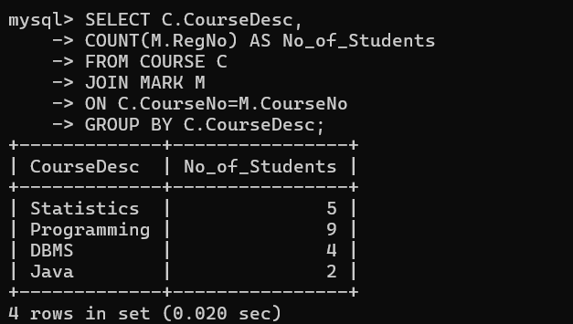
2:
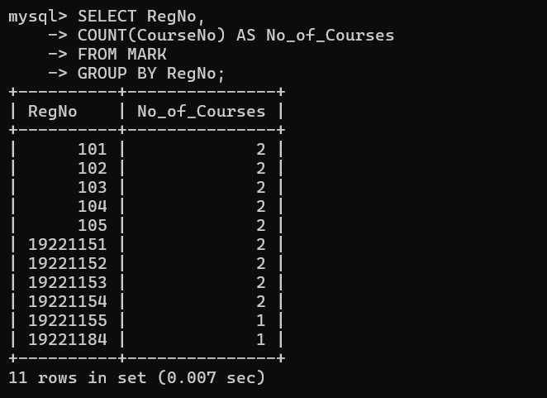
3:
